

**CSE 323**

**Project Report**

**On**

**Arduino Based 3-Way Traffic Light Controller**

Prepared by:

**Name:** Md. Marjan

**ID:** 1621396042

**Section:** 07

**Submitted To:** Mosabber Uddin Ahmed(MUA3 sir)

**Date of Submission:** 28th august 2019

Table of Contents

Introduction 3

Objective 3

Components Required 3

Circuit Diagram 4

Circuit Description 4

Working of the Traffic Light Controller Project 5

Limitations 5

Project Code 6

Actual Circuit Image 8

Conclusion 8

# Introduction

Traffic Lights or Traffic Signals are signaling devices that are used to control the flow of traffic. Generally, they are positioned at junctions, joints, pedestrian crossings etc. and alternate the priority of who has to wait and who has to go.

The traffic lights will provide instructions to the users i.e. Drivers and the people who walk by displaying lights of standard color. The three colors used in traffic lights are Red, Yellow and Green.

The system must be used to control the traffic lights for smooth and safe movement of traffic.

A simple system but can be extended to a real time system with programmable timings, pedestrian lighting etc.

# Objective

The aim of the project is to implement a simple traffic light controller using Arduino UNO, where the traffic is controlled in a pre-defined timing system.

The main objective of this traffic light controller is to provide sophisticated control and coordination to confirm that traffic moves as smoothly and safely as possible.

# Components Required

1. 3*Red LED Lights
2. 3*Green LED Lights
3. 3*Yellow LED Lights
4. 3*220ohm Resistors
5. Breadboard
6. Male To Male Connectors
7. Arduino Uno With Ide Cable

# Circuit Diagram

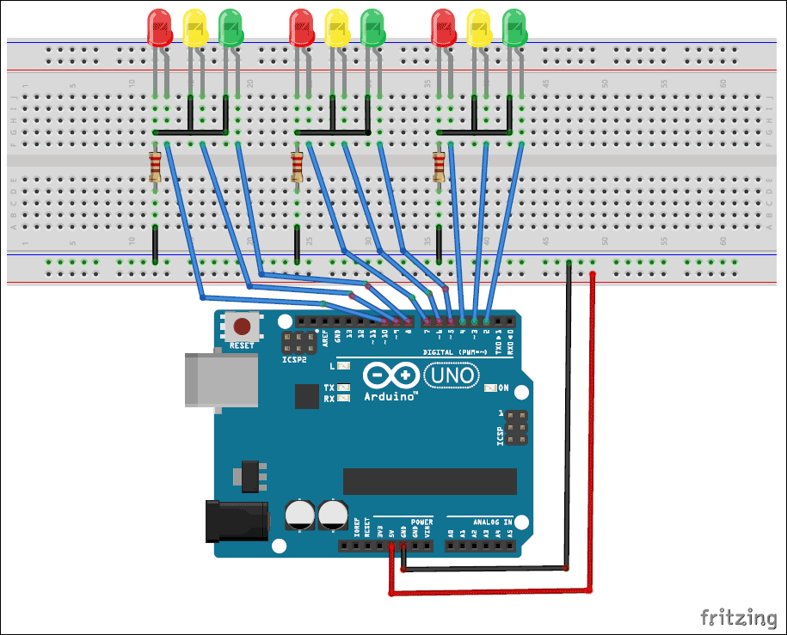

**Figure 1**

# Circuit Description

Since the project is a traffic light controller, the circuit consists of many LEDs, as we are executing traffic lights at a 3 way intersection. The project is a simple illustration of traffic light controller and hence no other extra components are used.

We need three LEDs of Red, Yellow and Green colors at each intersection. The intersection is divided in to four lanes: Lane1, Lane 2 Lane 3 and Lane 4.

All the LEDs are connected to the Arduino UNO’s digital I/O pins through respective current limiting resistors of 220ohm.

Arduino UNO in this project acts as source of current for all the LED i.e. it provides the necessary current to turn ON the LED.

### **Working of the Traffic Light Controller Project**

The actual time traffic light controller is a difficult piece of equipment which consists of power cabinet, main controller or processor, relays, control panel with switches or keys, communication ports etc.

In this project, a simple traffic light system for a 3 way intersection is implemented using Arduino UNO. Although it is not the ideal implementation for real life scenarios, it gives an idea of the process behind the traffic light control system.

In that, first the Lane 1 gets its Green light turned. Hence, in all the other Lanes, their corresponding Red lights are turned on. After a time delay of predefined time say 5 seconds, the Green light in the Lane 3 must be turned on and the Green light in the Lane 1 must be turned off.

As a warning indicator, the Yellow light in Lane 1 is tuned on indicating that the red light is about to light up. Similarly, the yellow light in the Lane 3 is also turned as an indication that the green light about to be turned on.

The yellow lights in Lanes 1 and 3 are turned for a small duration say 2 seconds after with the red light in the Lane 1 is turned on and green light in Lane 3 is also turned on.

The green light in Lane 3 is also turned on for a predefined time and the process moves forward to Lane 4 and finally Lane 2.

The system then loops back to Lane 1 where the process mentioned above will be repeated all over again.

# Limitations

The project is not suitable for actual implementation but just a demonstration of the process behind the system.

# Project Code

 void setup() {

  // configure the output pins

  pinMode(2,OUTPUT);

  pinMode(3,OUTPUT);

  pinMode(4,OUTPUT);

  pinMode(5,OUTPUT);

  pinMode(6,OUTPUT);

  pinMode(7,OUTPUT);

  pinMode(8,OUTPUT);

  pinMode(9,OUTPUT);

  pinMode(10,OUTPUT);

}

void loop()

{

  digitalWrite(2,1); //enables the 1st set of signals

  digitalWrite(7,1);

  digitalWrite(10,1);

  digitalWrite(4,0);

  digitalWrite(3,0);

  digitalWrite(6,0);

  digitalWrite(8,0);

  digitalWrite(9,0);

  digitalWrite(5,0);

  delay(5000);

  digitalWrite(3,1); //enables the yellow lights

  digitalWrite(6,1);

  digitalWrite(2,0);

  digitalWrite(7,0);

  delay(1000);

  digitalWrite(4,1); //enables the 2nd set of signals

  digitalWrite(5,1);

  digitalWrite(10,1);

  digitalWrite(2,0);

  digitalWrite(3,0);

  digitalWrite(6,0);

  digitalWrite(8,0);

  digitalWrite(9,0);

  digitalWrite(7,0);

  delay(5000);

  digitalWrite(9,1); //enables the yellow lights

  digitalWrite(6,1);

  digitalWrite(10,0);

  digitalWrite(5,0);

  digitalWrite(4,0);

  delay(1000);

  digitalWrite(8,1); //enables the 3rd set of signals

  digitalWrite(4,1);

  digitalWrite(7,1);

  digitalWrite(2,0);

  digitalWrite(3,0);

  digitalWrite(5,0);

  digitalWrite(6,0);

  digitalWrite(9,0);

  digitalWrite(10,0);

  delay(5000);

  digitalWrite(9,1); //enables the yellow lights

  digitalWrite(3,1);

  digitalWrite(7,0);

  digitalWrite(8,0);

  digitalWrite(4,0);

  delay(1000);

}

# Actual Circuit Image

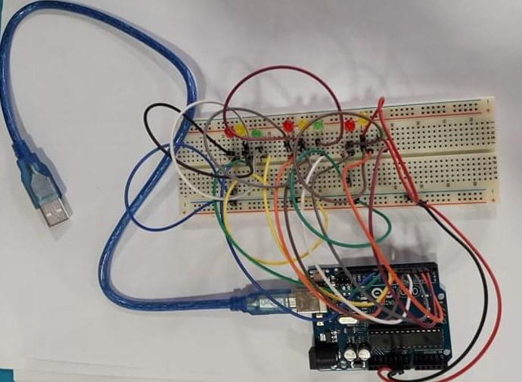

Figure 2

# Conclusion

Traffic light control system uses a worldwide color code i.e. a specific color order to enable color recognition for those who are color blind.

The actual time traffic light controller is a difficult piece of equipment which consists of power cabinet, main controller or processor, relays, control panel with switches or keys, communication ports etc.

In this project, a simple traffic light system for a 3 way intersection is implemented using Arduino UNO. Although it is not the ideal implementation for real life scenarios, it gives an idea of the process behind the traffic light control system.